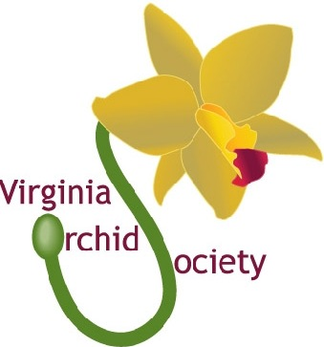
Annual Orchid Art Show
February 19-21, 2016
At Strange’s Greenhouse
12111 West Broad Street Richmond VA 23233
Show Theme to celebrate our tenth annual show is:
“ORCHID DECADE NCE”
TO RECEIVE AN ARTWORK ENTRY FORM CONTACT NANCY FARKAS AT
nfarkasarch@gmail.com or 804-672-7424
Awards will be given for top three entries in the following Classes:
Art, Photography, Sculpture, Stained Glass with separate classes for
Artwork by Youth (Under age 18)
Artwork must be delivered to Strange’s 8:00 AM-5:00 on February 18 and picked up promptly at 5:00 PM on Sunday February 21. There is no entry fee. Artists may sell their artwork if they wish. VOS will charge a 15% fee for all sales of artwork.

